
Life on Earth |  | Year 6 |  |  | Unit 4
Assessment task — Investigating mouldy bread: Model response
Name |  |  | Class
Teacher |  |  | Date

Part A: Plan an investigation about mould growth
You will plan, conduct and evaluate an investigation to identify factors that affect mould growth.
Your teacher will provide your group with three pieces of bread for your investigation.
You will measure mould growth using a 10 cm x 10 cm grid. Your bread will be exactly the same size, which will allow you to record the mould growth accurately on the grid. Use the assessment task Investigating mouldy bread: Student resource (Template) to assist with cutting the bread size.
Plan
 | - a) Record all the variables that could affect the amount of mould growth in the variable grid.
Type of bread (S) | Bread size (S) | Sandwich bag size (S)
Method of sealing the bag (S) | The amount of mould growth  (M) | Length of time for growth of mould (S)
When the bags are sealed (S) | Environment where the bread is stored (C)
 | b) On the variables grid.  - Label the variable you will measure with (M)  - Circle the variable that you will change and label with (C)  - Label the variables you will keep the same with (S).
 | - Complete your investigation question. For example:  What happens to the amount of mould growth on the bread when we change the environment where the bread is stored?

 | - Complete your prediction about mould growth in this investigation.  For example:  If we put a bread sample in a warm environment (e.g. on top of the fridge or left on a bench) then more mould will grow on the bread than a sample placed in the fridge because mould spores grow and germinate more in warm environments.
- Materials and equipment
3 slices of bread
3 resealable sandwich bags
clear packing tape
1 plastic knife
1 plastic plate
1 10 cm x 10 cm template (assessment task Investigating mouldy bread: Student resource) (to assist with cutting the bread to size)
permanent marker
 | - Describe potential safety risks and suggest how these risks could be reduced. Record your description in a table using the headings shown.  Potential risk How risk can be reduced  Bag may be opened and mould spores breathed in The sandwich bag with the bread must remain sealed and be disposed of by an adult when the investigation is completed.  Injury with the knife Ensure a plastic knife is used and it is placed in a safe spot away from the edge of the desk and not carried around the room when not being used. Have a first aid kit available.  Slipping on materials/equipment Ensure anything dropped, such as offcuts of bread or equipment, is picked up immediately.  Dropping equipment on your foot Wear closed-in shoes for foot protection.
 | - Identify the three locations you will place your bread samples in the investigation.  1. On top of the fridge 2. On a bench top 3. Inside a fridge

Method
 | - List the steps you will follow to complete your investigation. You will need to consider how you will determine the amount of mould growth.  Hint: Expose the bread to the air for a few hours before placing it in the sealed bag to help promote mould growth.  1. Collect your materials and equipment.  2. Leave the bread out for a few hours to expose it to the air and mould spores.  3. Cut the first slice of bread into a 10 cm x 10 cm square. (Use the grid from Investigating mouldy bread — Student resource (Template) to help measure this if necessary).  4. Repeat with the other two slices of bread.  7. Lightly spray each bread sample with water.  8. Place a bread sample in each resealable sandwich bag and close the bags.  9. Fold the top 1 cm of each bag over and seal each bag with packing tape so that the bag can’t be easily opened.  10. Label the bags 1–3 in the top left corner of the bag.  11. Place the bags in three different environments:  1. On top of the fridge 2. On a benchtop 3. Inside a fridge  12. Record observations of each bread sample during the investigation.  13. Place the clear grid template over a bread sample and collect data by recording the number of squares that contain mould. Record white mould by drawing a circle in the square where it appears. Other coloured mould is coloured appropriately.  14. Repeat for the other two bread samples.  15. Describe the appearance of each bread sample.  16. Repeat steps 13–15 every day for the length of the investigation.
 | Remember: After your resealable sandwich bags are taped shut, they must not be opened again.
Conduct
 | - Conduct the investigation

Part B: Observe, record and analyse results
Observations
 | - Record and organise your ongoing data and observations throughout the investigation on the following pages.  - Record observations of each bread sample on the grids.  Record white mould by drawing a circle in the square where it appears.  Other coloured mould should be recorded by drawing a circle and colouring appropriately.  - Note any other observations.  Describe the appearance of the bread and mould for each sample

Bag label: 1
Location: On top of the fridge
a) b)
Day 3: Green mould started to appear.
Day 5: Mainly bluish-green but some black mould appeared towards the centre of the sample. Most mould located in one corner of the bread sample.
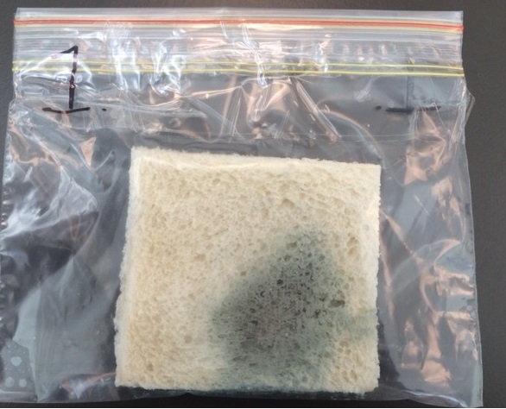

Bag label: 2
Location: Benchtop
a) b)
Day 4: Some white/grey mould
Day 5: Very yellow. Brown mould in some places. White/grey mould became fuzzy.
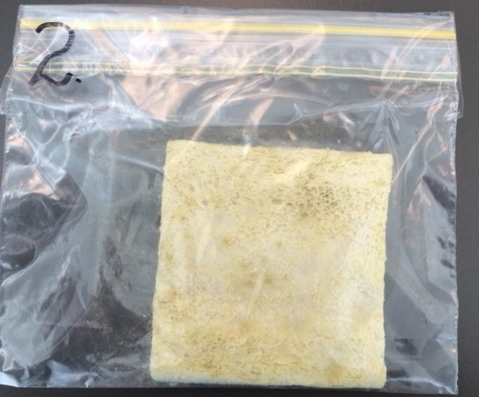

Bag label: 3
Location: In the fridge
a) b)
Day 4: No mould
Day 5: No mould
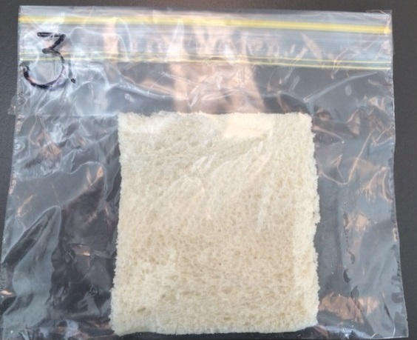

 | - Construct a table to record and organise your results.  You will need to record the number of ‘squares’ that contain each colour of mould you observed for each bread sample.  Hint: Some squares will be counted more than once if they contained different colours within the square.

Amount of mould on each bread sample
Bread location | Number of mould squares
 | White/grey mould | Yellow/brown mould | Blue/green mould | Black  mould
Bag 1:  On top of the fridge | 0 | 0 | 45 | 5
Bag 2:  Benchtop | 10 | 80 | 0 | 0
Bag 3:  In the fridge | 0 | 0 | 0 | 0

 | - Construct a side-by-side column graph that represents data from the investigation. Remember to:  give the graph a title  label the horizontal and vertical axes  use different colours to represent data  include a legend.

Amount of mould on each bread sample
Legend
White/grey mould
Yellow/brown mould
Blue/green mould
Black mould
Number of mould squares | 80
 | 70
 | 60
 | 50
 | 40
 | 30
 | 20
 | 10
 |  |  |  |  | Bag 1 |  |  | Bag 2 |  |  | Bag 3
 |  | Bread samples

Explain
 | - Using the graph, describe and analyse the amount of mould growth on the bread slices from the three environments.
The graph highlighted that different mould types grow in different environmental conditions. No bread samples in the investigation grew the same type of mould. The bread samples left on the benchtop and on top of the fridge both grew mould, but the mould type was different due to the different temperature of the two environments. The bread on top of the fridge had more blue/green mould and the bread on the bench had mainly yellow/brown mould. The graph indicated the yellow/brown mould grew significantly more throughout the investigation. The bread sample stored in the fridge showed no evidence of any mould type.
 | - Identify places where James should store his bread in the future to minimise mould growth. Justify your choice using your science knowledge and data from your investigation.
A response should include recommendations for places James could store his bread and include an explanation of why this place was recommended, supported by the results of the investigation.
For example:
The temperature in a cold place provides an environmental condition that discourages mould growth. In the investigation this was observed as the least mould grew on the sample in the fridge. The investigation data showed that a warm environment such as on top of the fridge is not a good place to store bread as the warm air becomes trapped inside the plastic bag and provides ideal conditions for the growth of certain moulds. The benchtop also resulted in the growth of a lot of yellow/brown mould, so although not as warm as the top of the fridge, room temperature also promotes mould growth.
The best place to store bread is in a dry, cool environment to reduce the conditions for mould growth. In winter months bread is probably fine left on the kitchen bench. In warmer months the fridge may be a better option to minimise growth as room temperatures. On top of the fridge is not a good idea as it provides a warm environment that is ideal for mould growth. Bread boxes are dark and also increase mould growth. The freezer would probably provide the best environmental conditions for the storage of the bread.

